Splinter Cell:Conviction
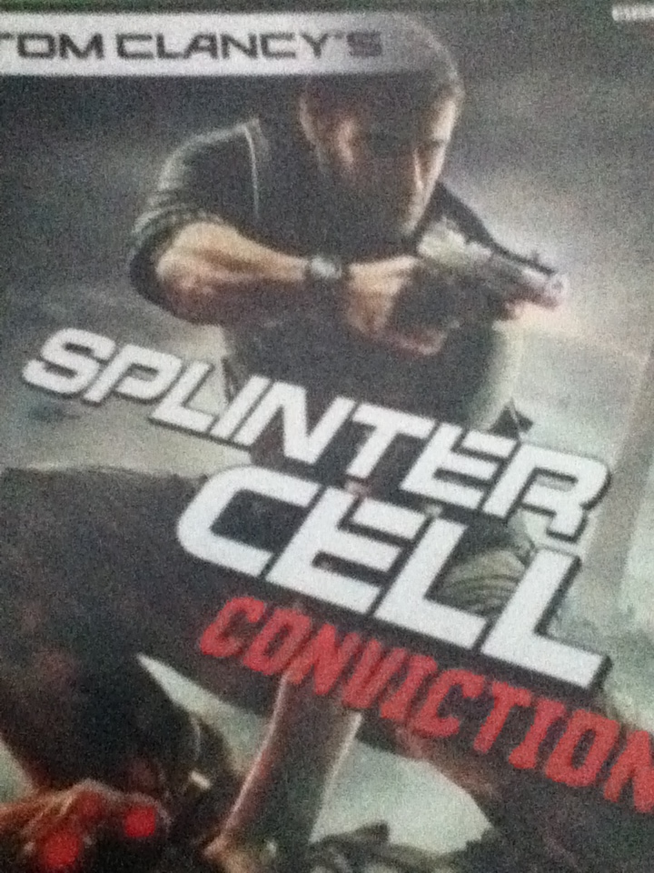

Based On The Game
By Joshua Carlock
[Chapter 1]
Sam Fisher was in Valletta,Malta,enjoying his vacation.Then,a waiter came to his table.”Excuse me,sir?””Yes?”,Sam answered as people walked by.”Phonecall for you.Please accept this, compliments of your caller.”Sam grabbed the pager off the tray and stuck the Bluetooth into his ear as the waiter walked off.”Sam?”,a woman asked.”Who is this?How did you find me?”Sam slunk into his chair.”Give me a little credit Sam.And don’t tell me you don’t recognize my voice,even after all this time.”Sam leaned over the table.”Grim.What do you want?”,he questioned.”To save your life.We can go from there.A team of armed men just entered the marketplace looking for you.They’re closing in on your position.Unless you do exactly what I say,this will be a very short conversation.””I’m not doing a damn thing until you tell me how you found me.”,Sam said,surprised.”We’re Third Echelon.”We’ve got an eye on everyone.
Look up.You’ll see it.”Sam dragged his eyes up past the building.A beacon was shining green in the sky as it hovered over the rooftop.”I see it.”,Sam said.”Good.Then I can take it back to safe altitude,and you can get moving.””You still haven’t told me how you found me.””Move!You’ve got multiple hostiles inbound on your position,and from where you’re at,you’re a sitting duck.Now get to that group of stalls in the market.There’s a lot of cover for you there.”,Grim answered.”Just like the old days,huh,Grim?””Just like the old days,Sam.Are you carrying?””Yeah,but I’d rather not risk a firefight when there are civilians around.””That’s very noble of you.But right now ,what matters to me is getting you out of there in one piece.So,get to that group of stalls,or,I can’t help you,Sam.”
Bam!Bam!Two pistol shots exploded into the air.People screamed and sprinted away from the mercenaries as Sam ran to the booths in the market.He slid into cover by one of them. “Good.Now,let’s get you a little closer to those targets in the light over there.Go cover to cover until you reach the luggage stand.Make it there,and I might be able to help you out.”Sam went cover to cover until he was inside.”I’m there.”,Sam said as a man with a gun and his hair slicked back,was talking on the phone.”Hang on.I’m tapping into the city’s power grid.That’ll let me overload the transformers near you and blow out those lights.”Suddenly,the lights started exploding,sparks flying everywhere.The man put his phone down to his side and stared at the explosions.

[Chapter 2]
20 Years Ago
“Daddy,daddy,daddy!”,Sam’s daughter,Sarah cried.He walked toward her bedroom door and opened it.”Hey,there kiddo.What’s wrong?”Sarah was in bed,holding her favorite bear.”I don’t like the dark.It’s scary.Turn on the light for me?Please?”Sam turned it on.”Aw,c’mon sweetie.There’s nothing to be afraid of in the dark.Sometimes,darkness is a good thing.Like when you want to go to sleep.””I can just go to sleep with the light on.”,she said excitedly.Sam turned the light off again.”When it’s light,you can’t see into a place that’s dark.But,when it’s dark,you can see what’s around you much better.””Really?””Really.So,if there’s monsters or bad people around,you can see them.And,if you’re in the dark,they can’t see you.”,he said trailing off to the side.”I can’t see you either.Can you please turn the light back on?””Okay,then how about this?There’s one really cool thing I didn’t show you yet.””There is?Show me!”Sam acted like he was thinking for a minute.”Okay,here it is!”Sam sat down by Sarah.”When you’re in the dark and your eyes get used to it,you can see all sorts of things around you really well.And then you can do stuff with them.””Like what?””Take a look at your mobile.You can see it really well,right?If there were monsters standing underneath it,because I can see it,maybe I could make it fall on them-“”And it would fall on their heads and they wouldn’t be bad anymore?”Sam slappd his knee.”That’s my girl!”Crash!The living room door busted open.Glass fell all over the floor.”Daddy?What was that?””Shhhh.Daddy needs you to stay in bed now.OK?He’s going to shut the door and he’ll be back real soon.”,Sam told Sarah as he tucked her in.”Ok,daddy.I love you.””Shhh,stay in bed.” Grim’s voice faded back into his mind.“There you go,Sam.Nice and dark just the way you like it.””We have to find Fisher.”,the thugs said as Sam was hiding.One of the thugs moved over to a dresser.He looked behind it.Then,Sam brought his silenced pistol up and shot one of the thugs in the head.The other one saw Sam and started shooting.Sam moved to the next cover spot,right beside the thug.”You have to come back!”Sam snuck behind him and with a silent whistle,shot him in the head.Another thug then came by.Sam jumped over the dresser quickly.”Come out and show yourself!Be a man!Come out and play!”Bam!As the thug hid behind cover,Sam jumped back over and shot him in the stomach.He then fell to the ground.

[Chapter 3]
20 Years Ago
Sam stood behind the door,listening.”What’d you got,man?You got anything good?” Sam opened Sarah’s bedroom door and crept toward them.”This place is crap.””Well,you picked it.””Yeah,you said we could get a little thou,easy.””I heard there were medals and crap we could fence in here.””The lady that lives here is hot,maybe we could wait for her to come home.””Take it out in trade?”Sam passed the stairs.Then,a man with a handgun came out of his bedroom.”Crap!”Sam turned around,grabbed the gun,punched him in the face and shot him in the forehead.He then shot the other two thugs and killed them.The gun shot made a hole in the dining room door.Sarah opened her door.”Dad?What did you do to them,dad?”Sam put the gun in his pocket and came to Sarah.He turned her around.”Sarah,baby don’t look…”Grim’s voice was crawling into his head.”Sam?Sam?What are you doing?””What are you doing,daddy?””Sam,talk to me.Sam?Sam?Are you there?Come on,don’t check out on me.””Grim.””There you are.They brought in some reinforcements and the man calling the shots is with them.Get ahold of him.I’ll ID him and you’ll figure out what questions to ask.”Sam put his gun up and walked through the market.A man stood by a wall,while two people were talking at one of the stands,about 10-15 meters away.Sam crept behind the man,then snapped his neck.Sam marked his targets,then,shot.The gun shots were faint.He was crouched down and walked over through another part of the market.”I’ve got an ID on the leader,Sam.His name is Dmitri Gramkos,a local street-level boss.He hires himself and his gang out on a regular basis.””Who’s he working for now?””Why don’t you ask him?””I think I will.”He hid behind cover while four men were by a stand.”You see anything?””Nah,man.””This Fisher guy’s smart.”While the two guys were talking,a man with a jacket came to where Sam was.Sam pulled his gun out and pushed it into his face.He had hit him hard enough to kill him.Sam looked at the other three.Dmitri was standing beside them about 15 meters away.Sam marked two,shot one behind them,then shot the two.Dmitri started shooting as Sam hid behind another stand.He had a Desert Eagle in his hand.Sam started to run up to him.”Screw this!I’m outta here!”Gramkos descended down the stairs beside him into the bathroom.Sam followed.Dmitri locked the door,then started shooting through with a shotgun.He barely missed.Sam busted through the door.Dmitri flew back and hit the wall.”Looking for me,asshole?”Sam came to him.Dmitri pulled his Desert Eagle out.Sam grabbed and pointed it the other way.He pulled the trigger,twisted Dmitri’s hand the other way,grabbed the gun,swung it over,ejected the clip,dropped the gun,and grabbed Dmitri by the throat.”No more playing around!Who sent you?””I’m not telling you a damn thing!”Sam pushed him into a wooden bathroom stall door.He shoved his head into it.Dmitri fell down.Sam kneed him in the face and the door cracked and flew open.A man was hiding in it.”Whoah!I didn’t see nothing,man,I swear it!”Sam pulled him back up.”Ok…enough.You wanna know who sent me?It’s Kobin,Andriy Kobin.”He coughed.”Runs drugs…guns..anything people want,he gets it for them.””Not good enough.Why does Kobin want me dead?”Sam tightened his grip.”Don’t..Please…stop.”Sam dragged him over to the sink,smashed his face into the mirror,and punched him through the sink.”Damn!”
“He..he drove the car that killed your daughter.Used to brag about it,you know..huh..heard you were coming so he hired me to kill you before you killed him…””You should refund his money.Where do I find him?””You don’t understand…oooh!He’ll kill me..hunhhhh.”Sam kneed him in the stomach,then punched him in the face.Sam picked him up again.”In the city!The old museum on King George Street..it’s his place now..guards out front and on the sides..don’t tell him I told you.””Oh,I’m not gonna tell him a damn thing.”Sam released Dmitri and he fell to the floor.Sam then walked out.
[Chapter 4]

